



LAB MANUAL
Simple inventory management system using super()

Disclaimer: The content is curated from online/offline resources and used for educational purpose only
Simple inventory management system using super()

Objectives:
- To understand and implement inheritance using the super() function in Python.
- To create a base class Item that represents a generic item in an inventory.
- To create specialized subclasses PerishableItem and NonPerishableItem that inherit from the Item class.
- To override methods in the subclasses and utilize super() to call the base class's methods.
- To simulate an inventory system where perishable and non-perishable items can be managed and their details displayed.
Problem Statement:
Imagine you are building a simple inventory management system for a store. You have a base class Item that represents a generic item in the inventory, and you want to create specialized subclasses like PerishableItem for food items that have expiration dates and NonPerishableItem for items that don’t expire. Each item should have a method to display its details.
Procedure:
Task 1: Define the Base Class Item
Task 2: Define the Derived Class PerishableItem
Task 3: Define the Derived Class NonPerishableItem
Task 4: Instantiate Objects and Display Item Details

Code:
Task 1: Define the Base Class Item
The Item class represents a general item in the inventory, with attributes for name and quantity.
The display() method prints the item name and quantity.
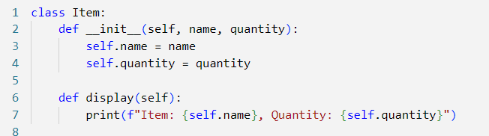

Task 2: Define the Derived Class PerishableItem
The PerishableItem class inherits from the Item class and adds an expiration_date attribute.
The __init__() method calls the parent class's constructor using super() to initialize name and quantity. The display() method overrides the base class's method, using super().display() to print common details, followed by the expiration date.

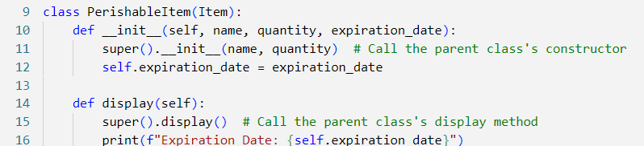

Task 3: Define the Derived Class NonPerishableItem
The NonPerishableItem class inherits from Item but does not need any additional attributes.
The display() method overrides the base class's method, using super().display() to print common details, followed by a message indicating that the item does not expire.

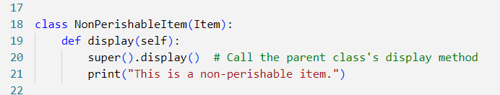

Task 4: Instantiate Objects and Display Item Details
An instance apple of the PerishableItem class is created with a name, quantity, and expiration date. An instance canned_beans of the NonPerishableItem class is created with a name and quantity. Both objects call the display() method, demonstrating how inheritance and method overriding work.
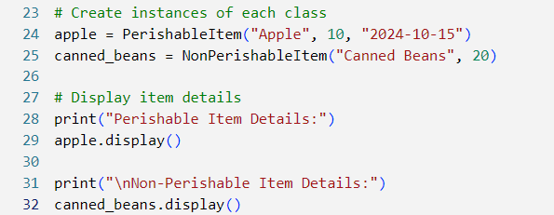

Output:
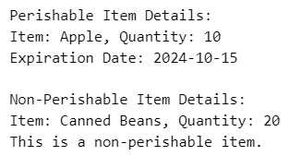
This program demonstrates a simple inventory management system using inheritance and the super() function. The base class Item provides common attributes and methods, while specialized subclasses like PerishableItem and NonPerishableItem extend the base class with specific behaviours.

